# VISVESVARAYA TECHNOLOGICAL UNIVERSITY



JNANA SANGAMA, BELAGAVI – 590 018



**Assignment Report on**

Data Visualization

**Submitted By**

### Shivam Singh Bhadoria - 1RN21CD049

**Under the Guidance of**

**Ms. Vinutha S**

**Asst. Professor Department of CSE (Data Science)**



**RN SHETTY TRUST®**

RNS INSTITUTE OF TECHNOLOGY

Autonomous Institution Affiliated to VTU, Recognized by GOK, Approved by AICTE (NAAC ‘A+ Grade’ Accredited, NBA Accredited (UG - CSE, ECE, ISE, EIE and EEE)

Channasandra, Dr. Vishnuvardhan Road, Bengaluru - 560 098 Ph:(080)28611880,28611881 URL: [www.rnsit.ac.in](http://www.rnsit.ac.in/)

**2024-2025**

# Table of Contents

1. Introduction
2. Question 1: Statistical Analysis of Apple Stock Data
3. Question 2: TikTok Video Performance Analysis
4. Question 3: Comparison and Composition Plots
5. Question 4: Matplotlib Basics with Agriculture Crop Yield Data
6. Question 5: Displaying Basic Plots with Matplotlib
7. Question 6: Advantages of Seaborn and Aesthetic Control
8. Conclusion
9. References

## Introduction

This report presents solutions to various data analysis and visualization tasks using Python libraries such as Numpy, Pandas, Matplotlib, and Seaborn. The datasets used include Apple stock data, TikTok video performance data, and agriculture crop yield data. Each question addresses a specific aspect of data analysis and visualization.

## Question 1: Statistical Analysis of Apple Stock Data

### Objective

To demonstrate the calculation of mean, median, mode, and standard deviation using Numpy and Pandas with the Apple stock dataset.

### Code Snippet:

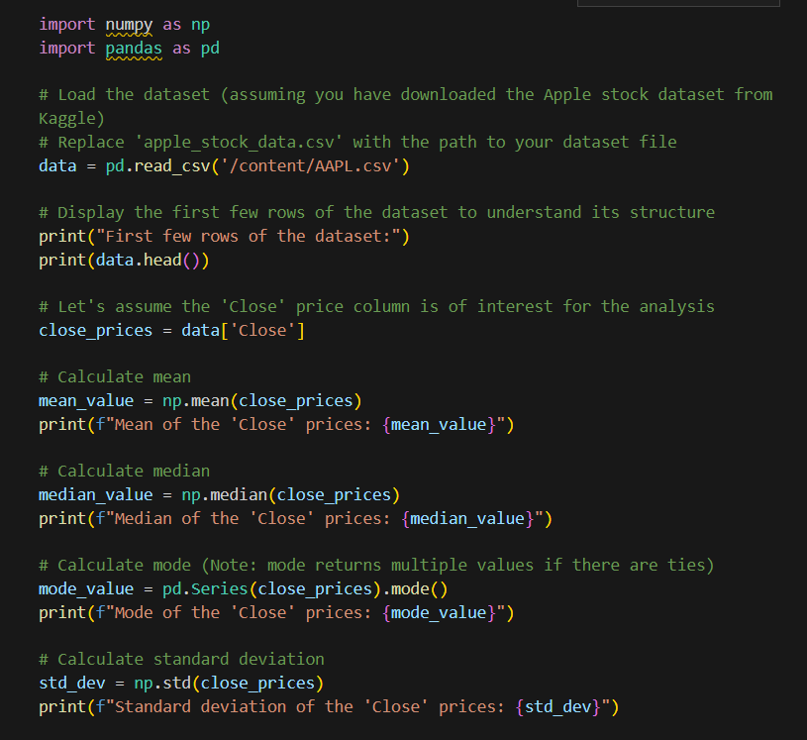

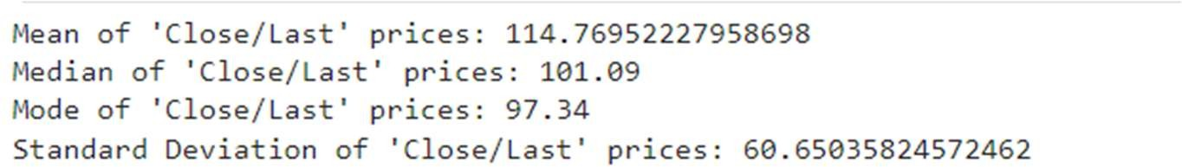**Output:**

## Question 2: TikTok Video Performance Analysis

### Objective

To perform basic to advanced operations using Numpy and Pandas on a TikTok video performance dataset.

### Code Snippet:

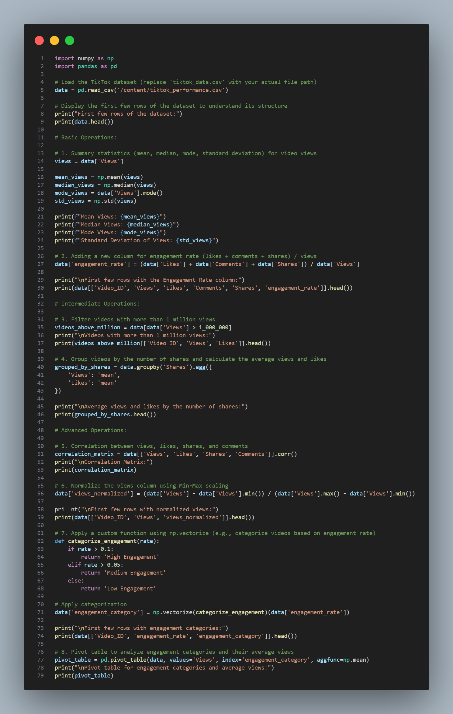

**Output:**

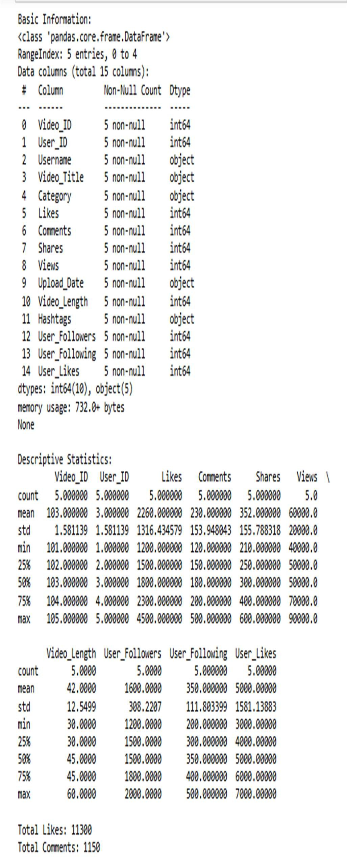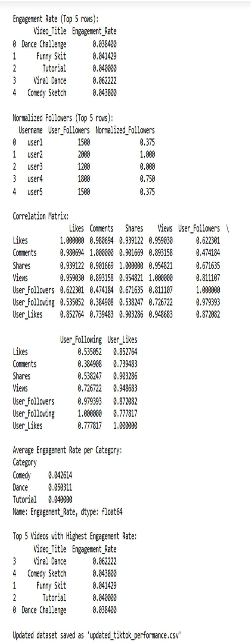

## Question 3: Comparison and Composition Plots

### Objective:

To plot different comparison plots and composition plots using a suitable dataset.

**Code Snippet:**

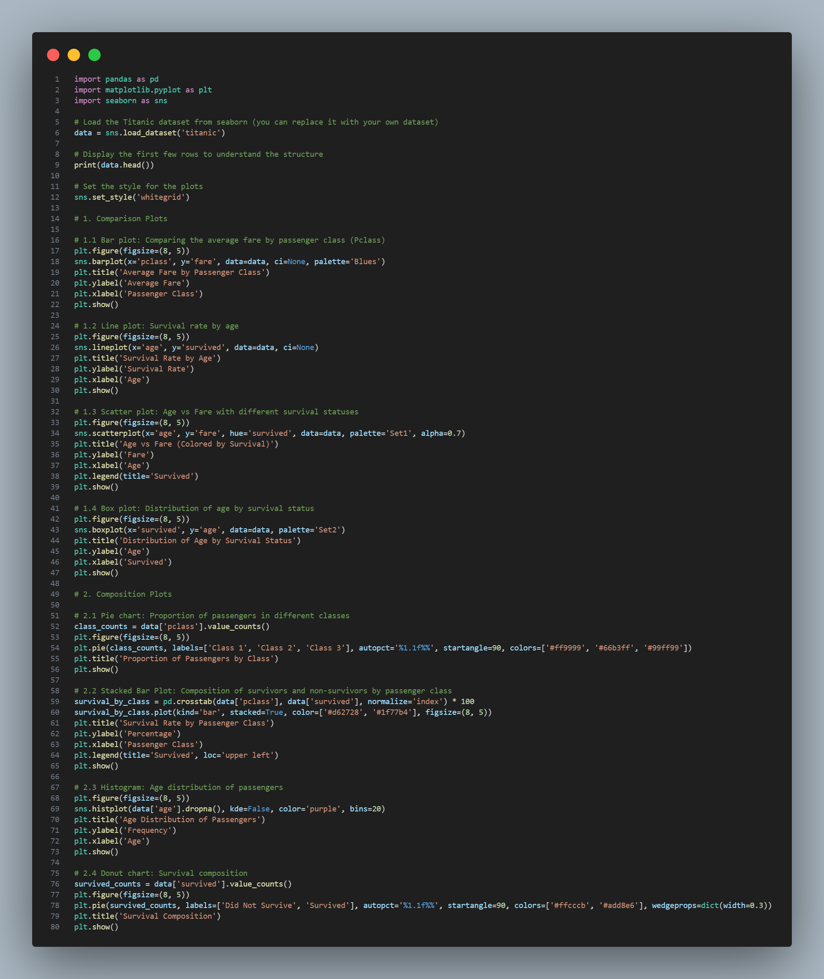

**Output:**

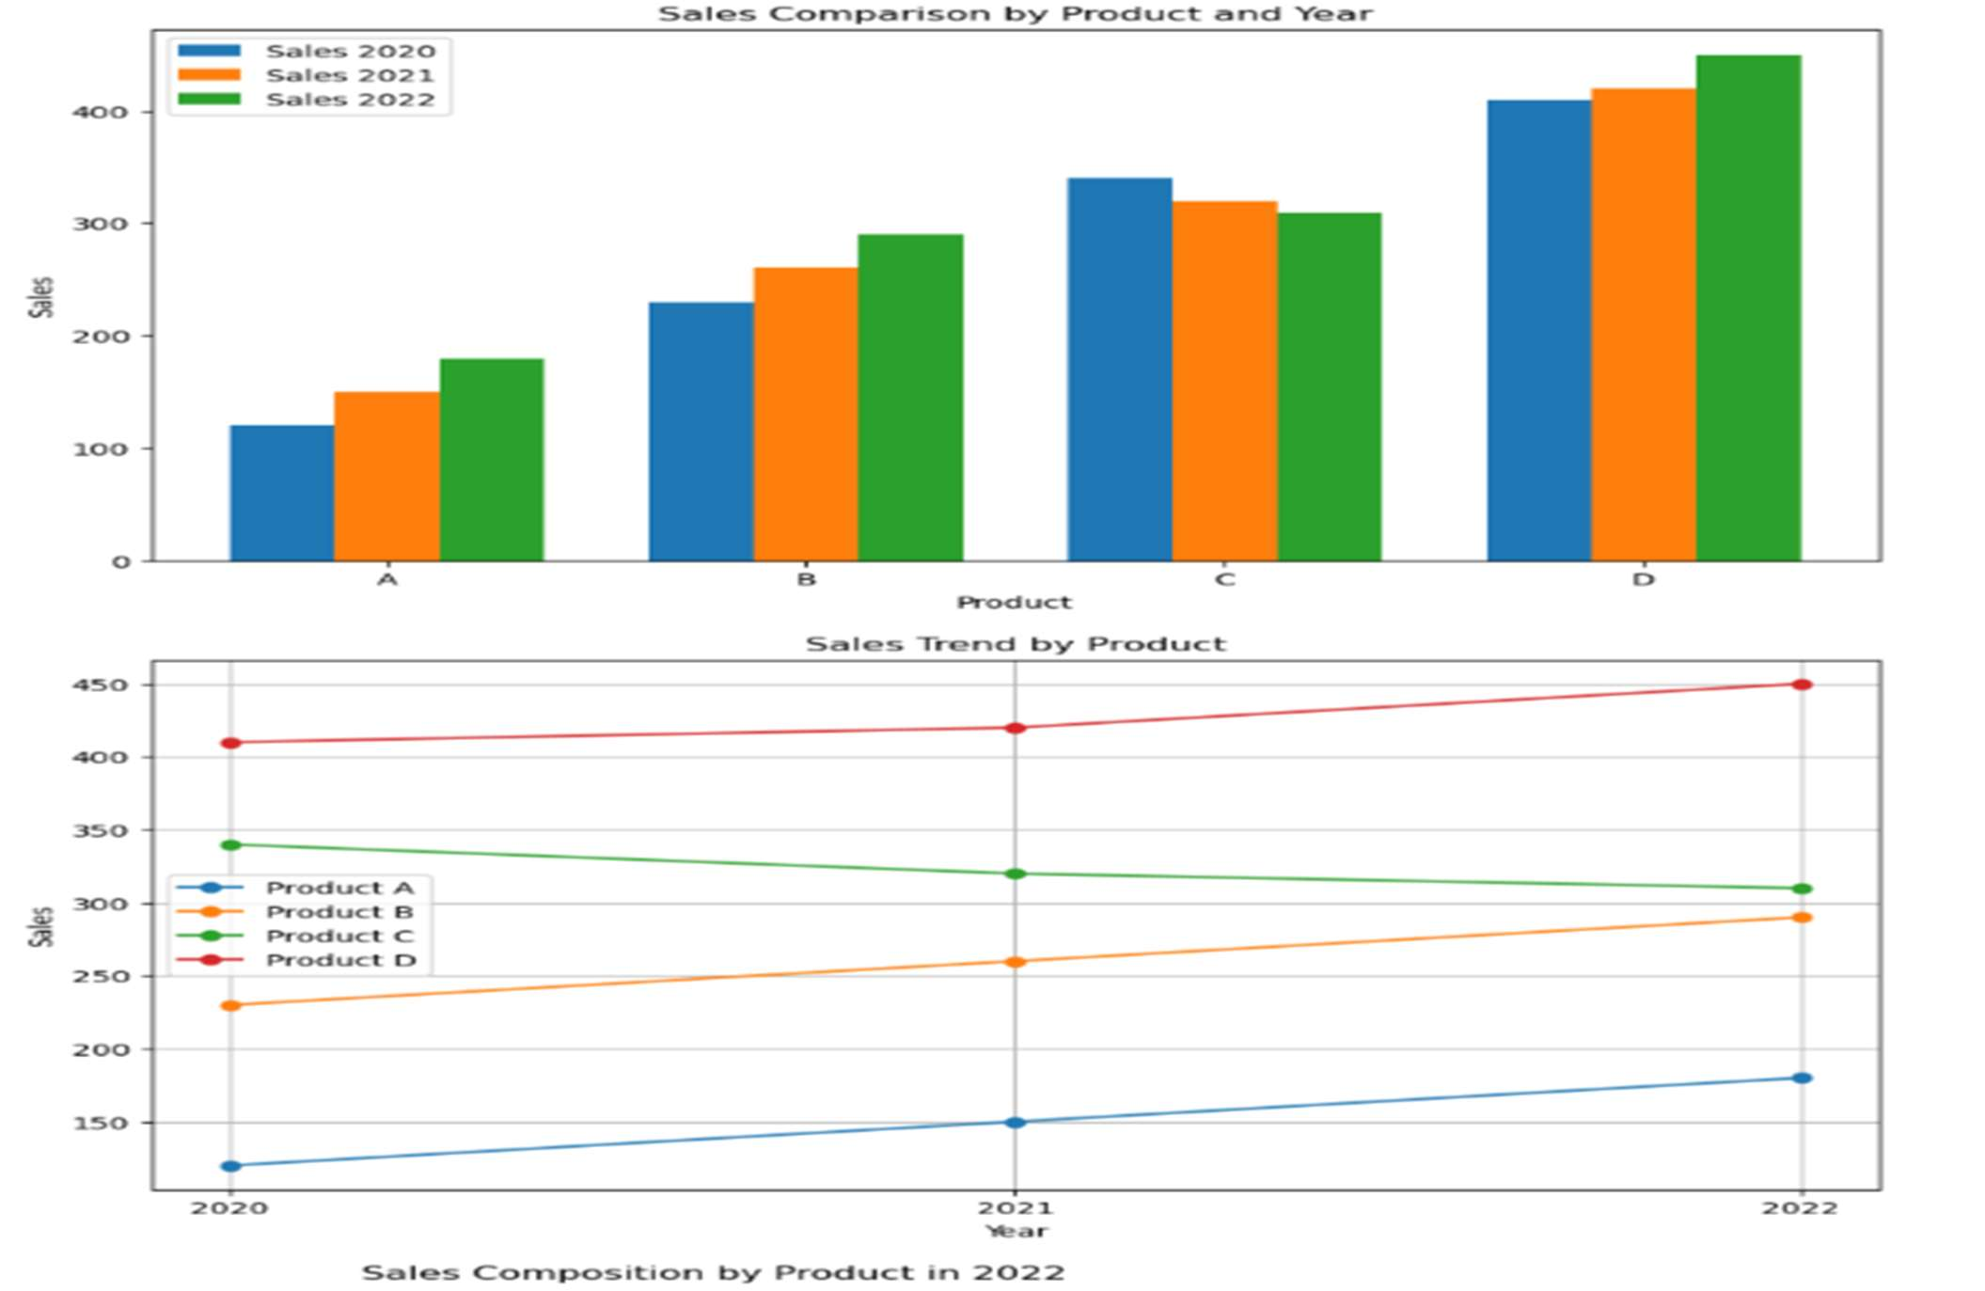

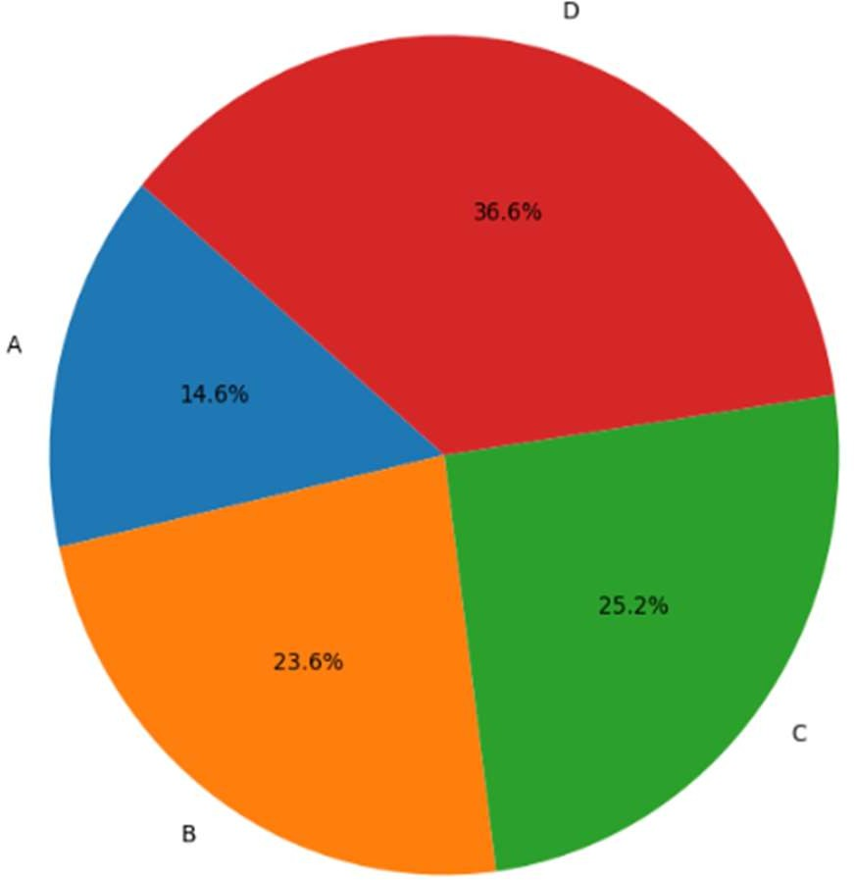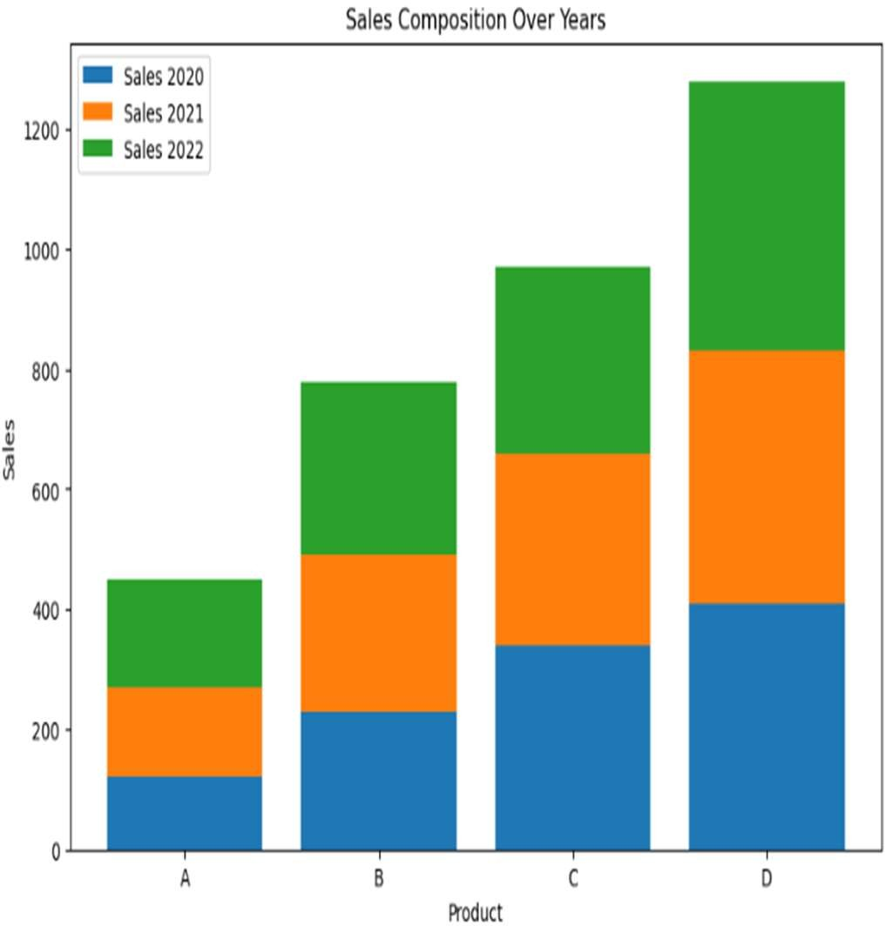

## Question 4 Develop a code using Matplotlib performing all Pyplot basics operation basic text and legend using Agriculture crop yield data set

### Objective

To perform basic operations using Matplotlib with an agriculture crop yield dataset

**Code Snippet:**

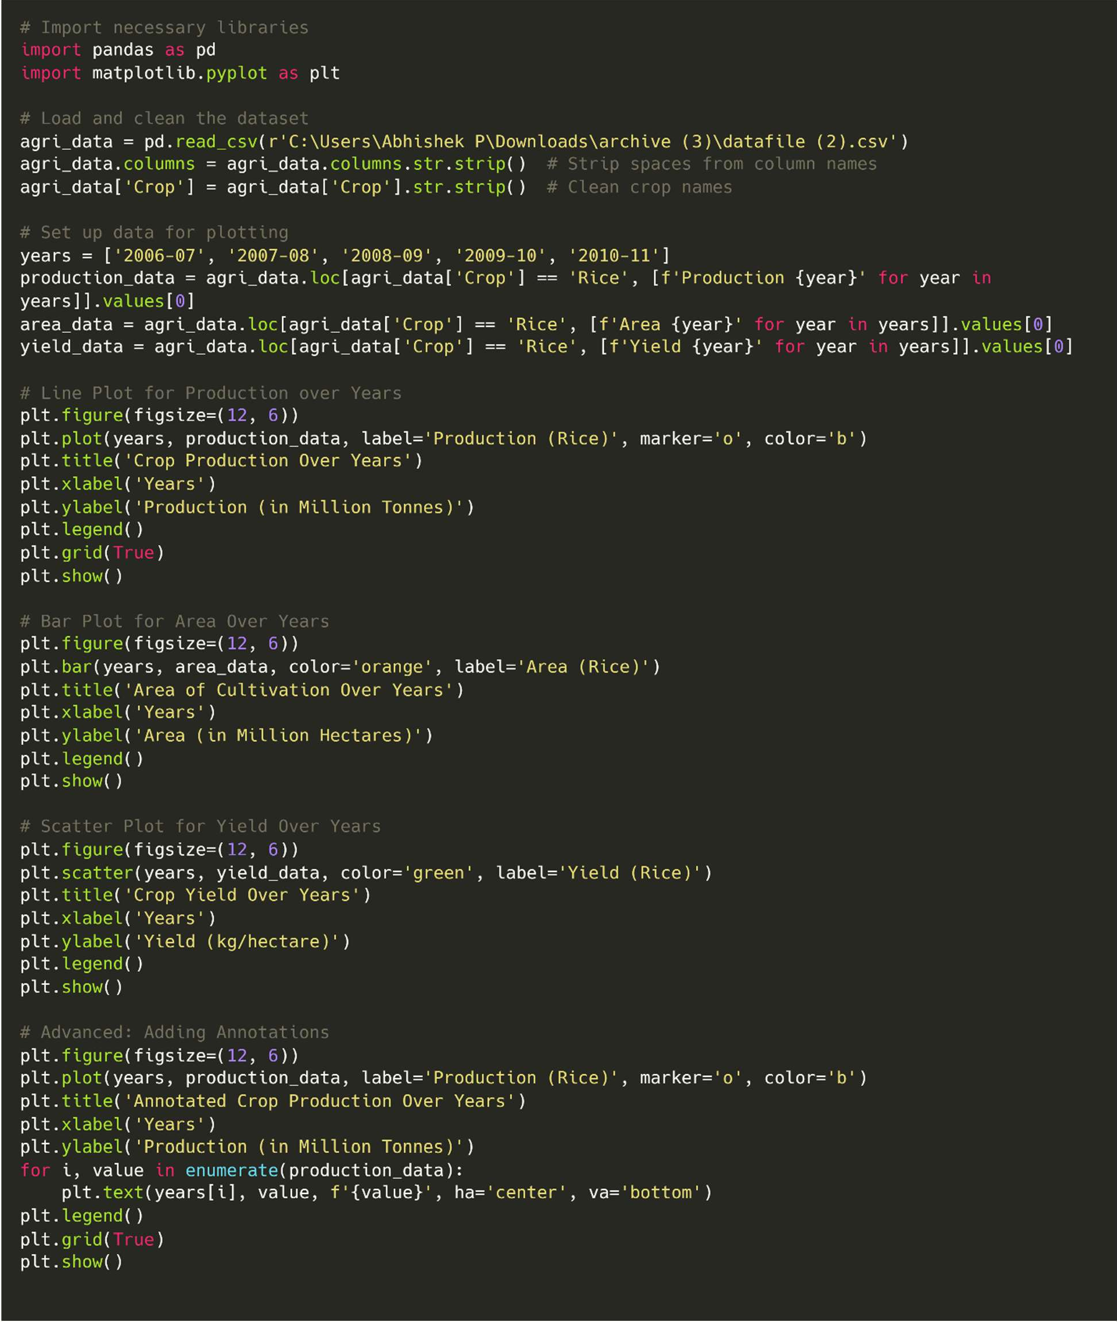

**Output:**

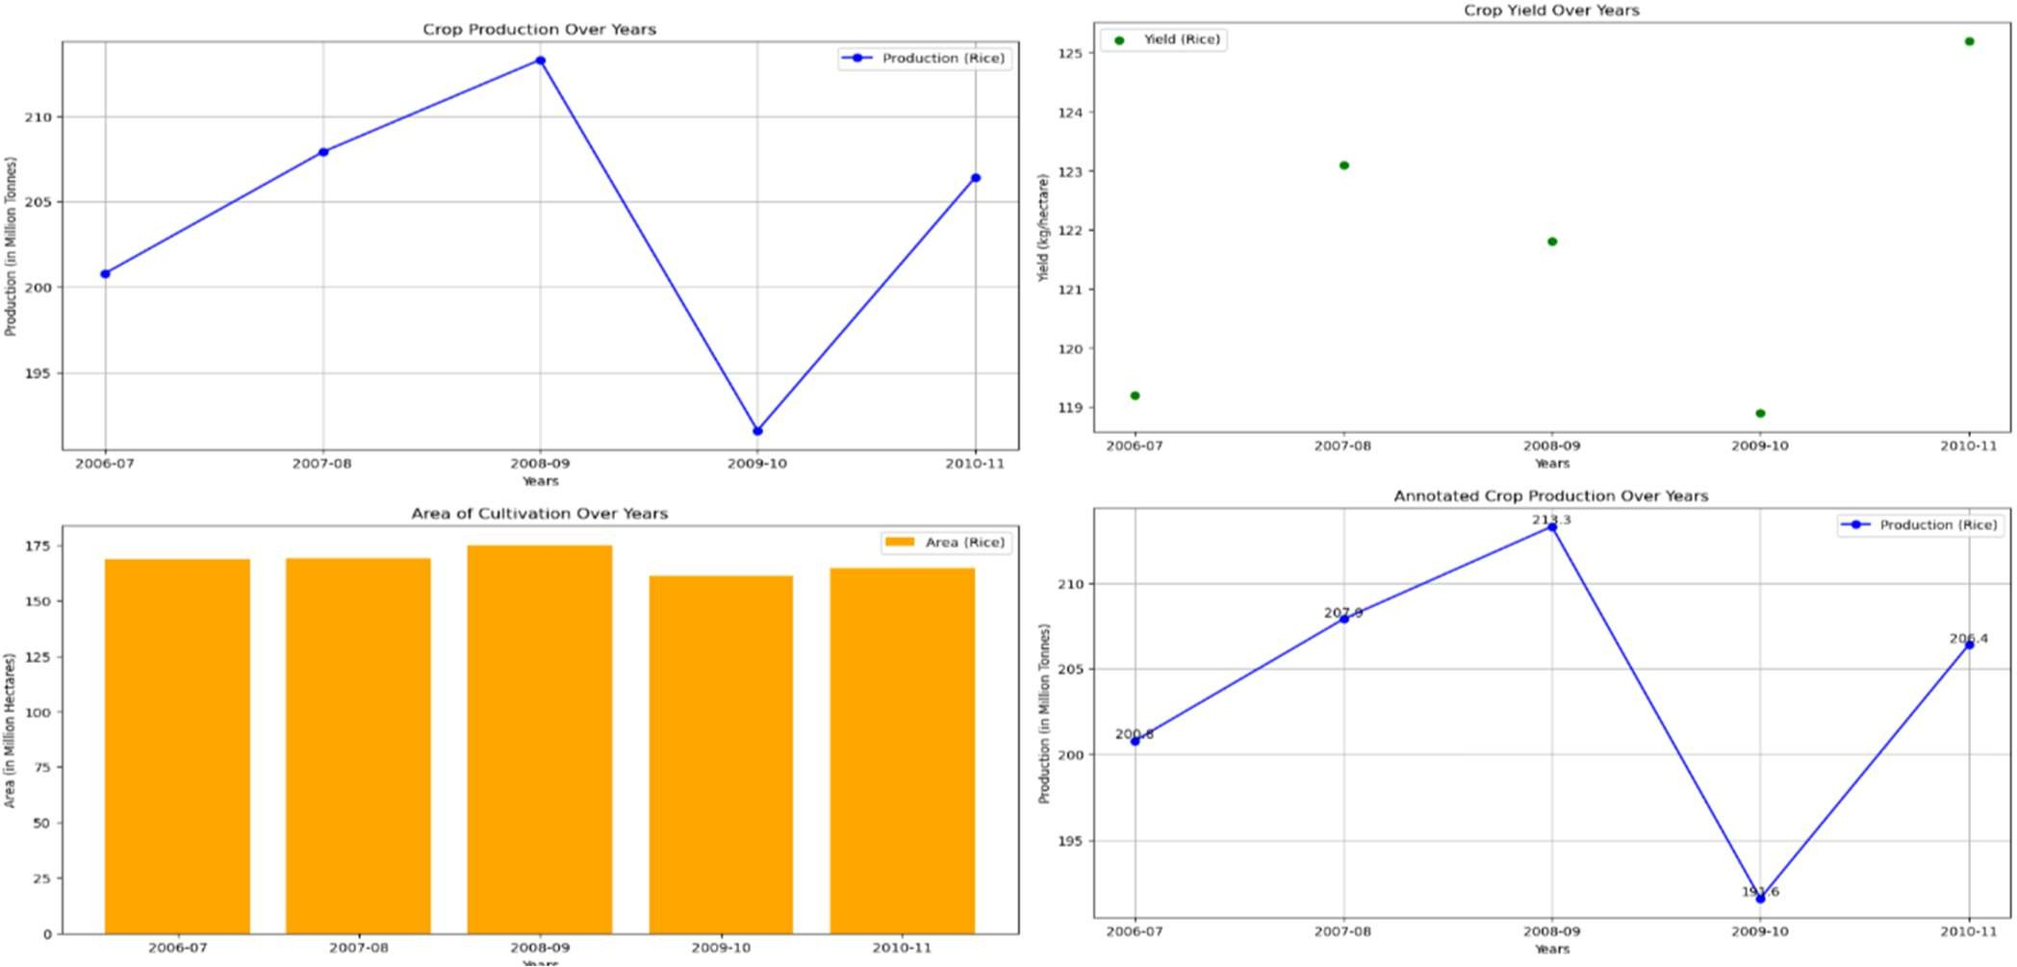

## Question 5: Displaying Basic Plots with Matplotlib

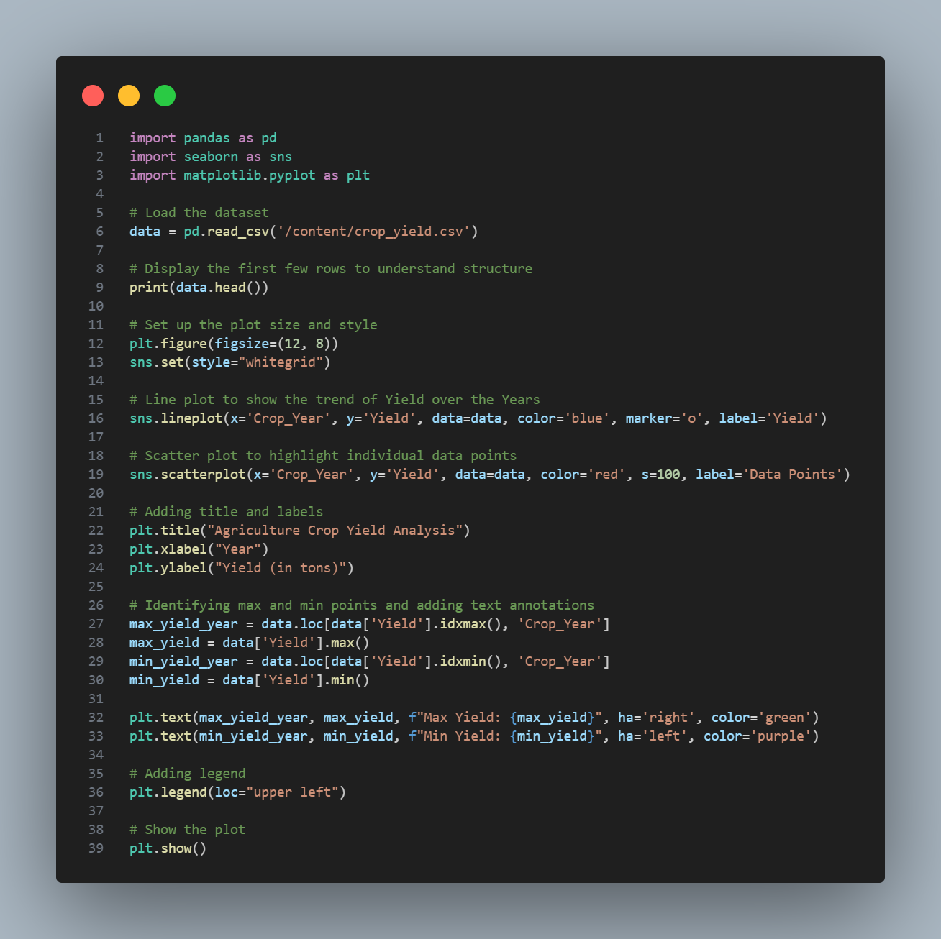

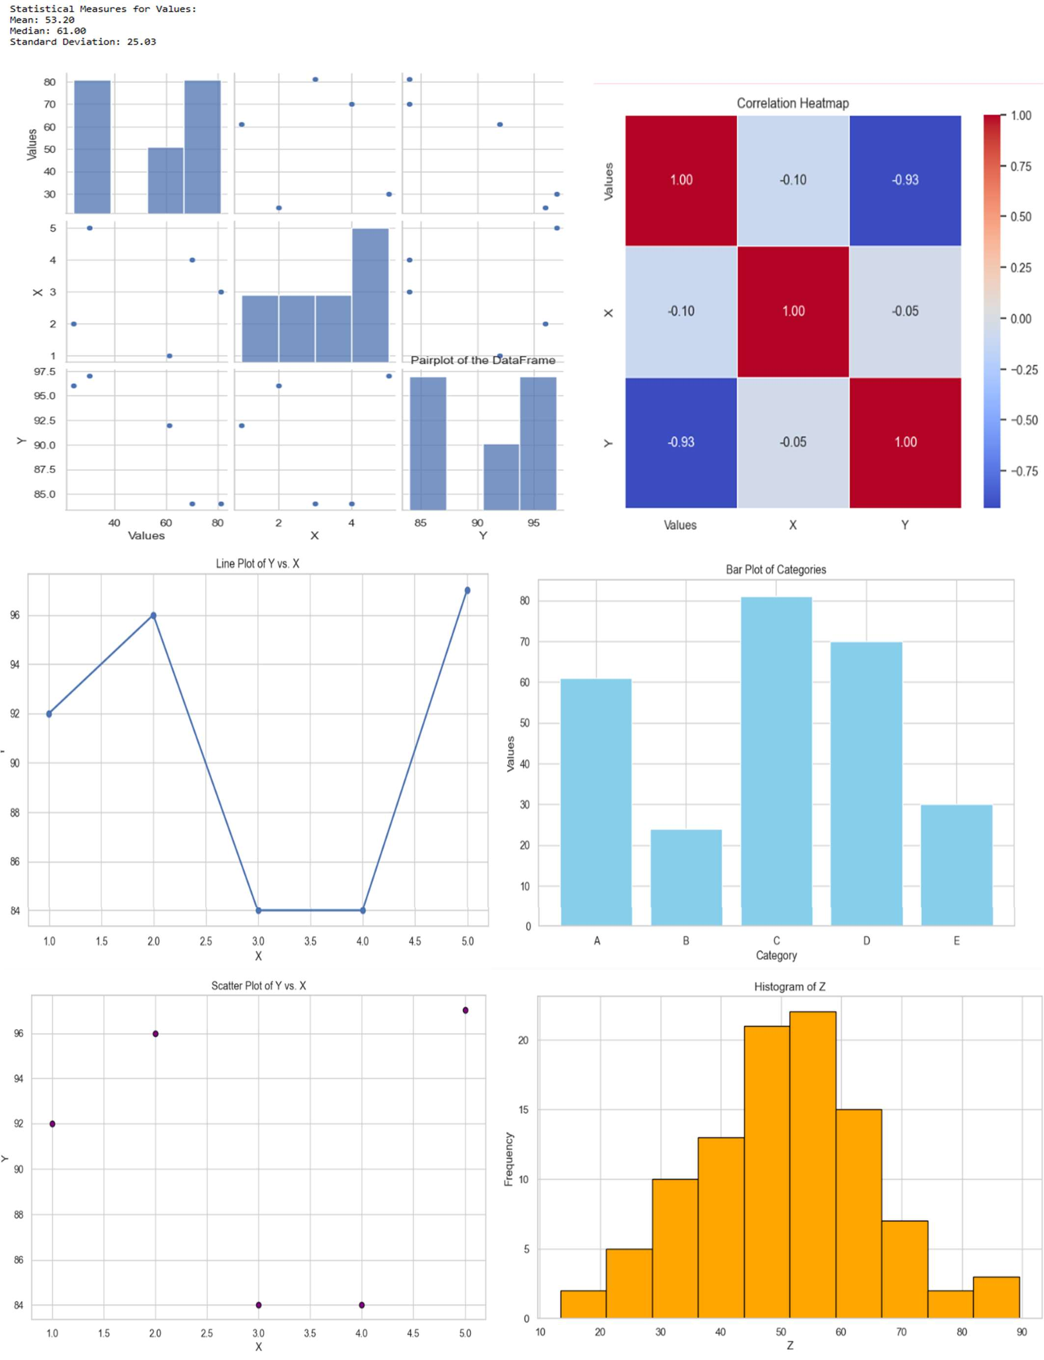**Output:**

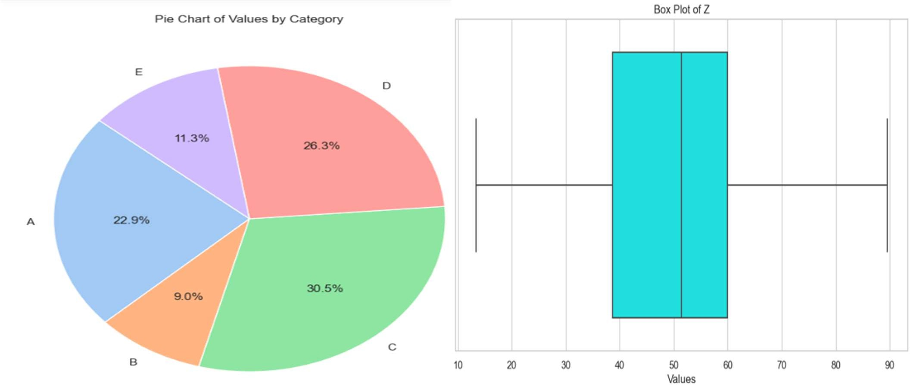

## Question 6: Advantages of Seaborn and Aesthetic Control

### Objective

To illustrate the advantages of Seaborn and demonstrate aesthetic control using Seaborn. Seaborn is a powerful visualization library in Python that builds on Matplotlib and provides a high-level interface for drawing attractive and informative statistical graphics. Below are

some advantages of using Seaborn compared to Matplotlib, along with a code snippet

illustrating how to control figure aesthetics.

### Advantages of Seaborn over Matplotlib Simplified Syntax:

Seaborn provides a more user-friendly API for creating complex visualizations with fewer lines of code. It handles many tasks automatically, such as setting up axes and handling legend placements. Statistical Functions:

Seaborn comes with built-in support for visualizing statistical relationships and distributions, making it easier to create plots that convey data distributions, trends, and comparisons. Enhanced Default Aesthetics:

Seaborn's default styles are more visually appealing than Matplotlib's. It offers several themes (e.g., darkgrid, whitegrid) that can enhance the overall appearance of plots without extensive customization. Integration with Pandas:

Seaborn works seamlessly with Pandas DataFrames, allowing for easy plotting of data contained in DataFrames with straightforward syntax. Advanced Plot Types:

Seaborn supports a variety of specialized plot types (e.g., violin plots, pair plots, heatmaps) that are not available in Matplotlib without additional coding. Controlling Figure Aesthetics with Seaborn When creating visualizations, controlling aesthetics is crucial for enhancing clarity and appeal. Seaborn provides various ways to adjust figure aesthetics, including color palettes, font sizes, and styles.

Here’s how to implement and control figure aesthetics in the enhanced box plot example:

### Code Snippet:

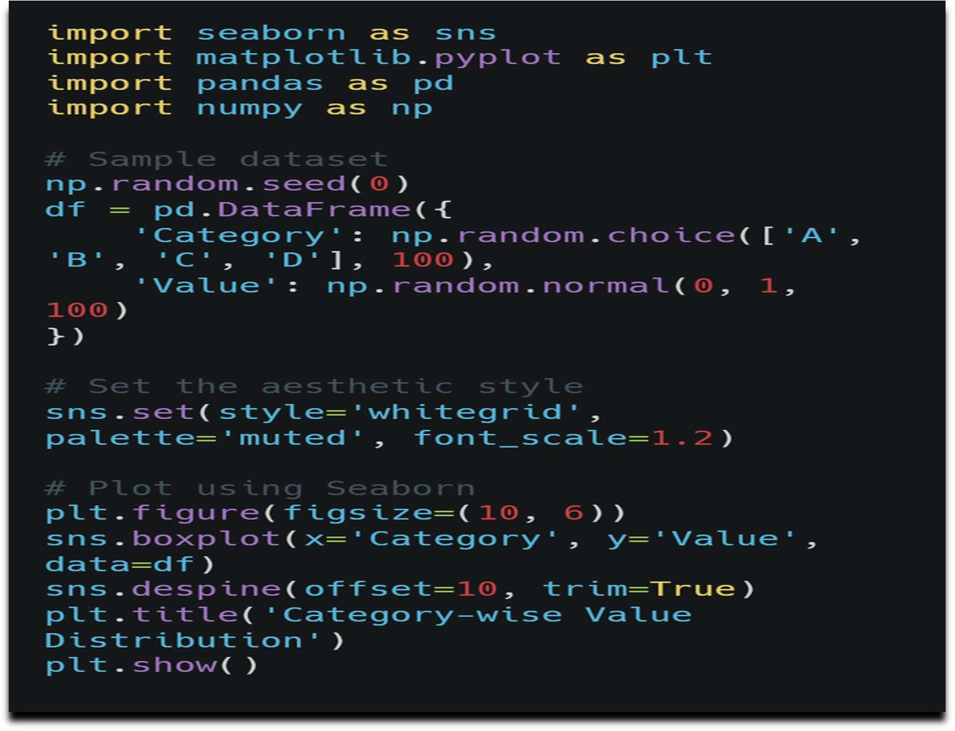

**Output:**

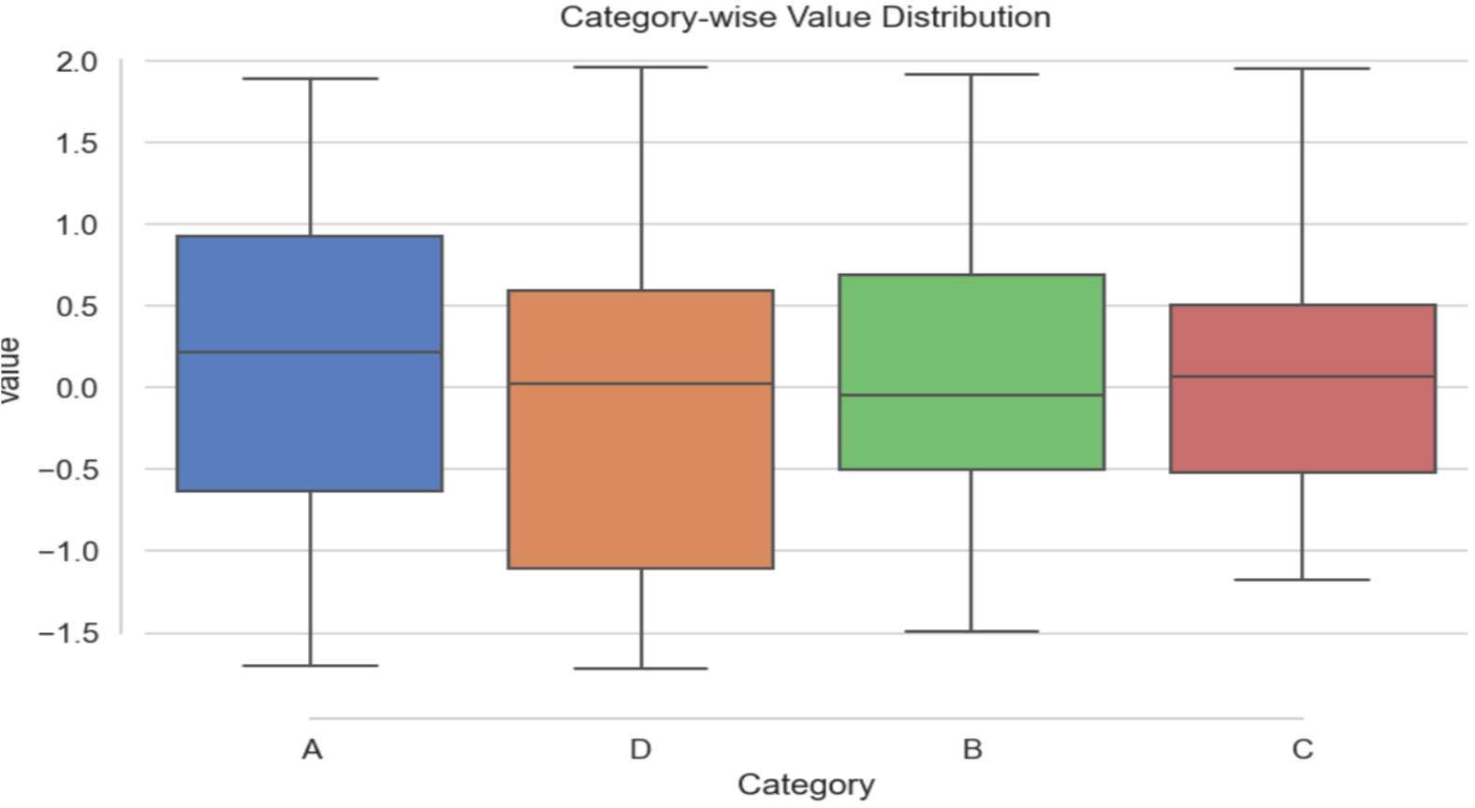

This snippet demonstrates Seaborn's ability to enhance plot aesthetics through sns.set, which adjusts the style, color palette, and font sizes for a cohesive look. The sns.despine function removes the top and right borders, adding to the minimalist and modern aesthetic, while the muted color palette keeps visual elements subtle yet distinctive.

Seaborn thus provides powerful tools to control and enhance figure aesthetics, making it ideal for producing visually engaging, insightful, and professional visualizations with minimal code.

## Conclusion

This report demonstrates various data analysis and visualization techniques using Python libraries such as Numpy, Pandas, Matplotlib, and Seaborn. Each question addresses a specific aspect of data analysis and visualization, showcasing the capabilities of these libraries.

## References

* + Pandas Documentation
  + Numpy Documentation
  + Matplotlib Documentation
  + Seaborn Documentation

**GitHub Repo Link**: https://github.com/Shivamsingh300/DVREPORT1